**Installing Windows 10 on Virtual Box**

# Install VirtualBox on Windows

1. To obtain Oracle VirtualBox go to <https://www.virtualbox.org/wiki/Downloads>
2. Click on Windows hosts.

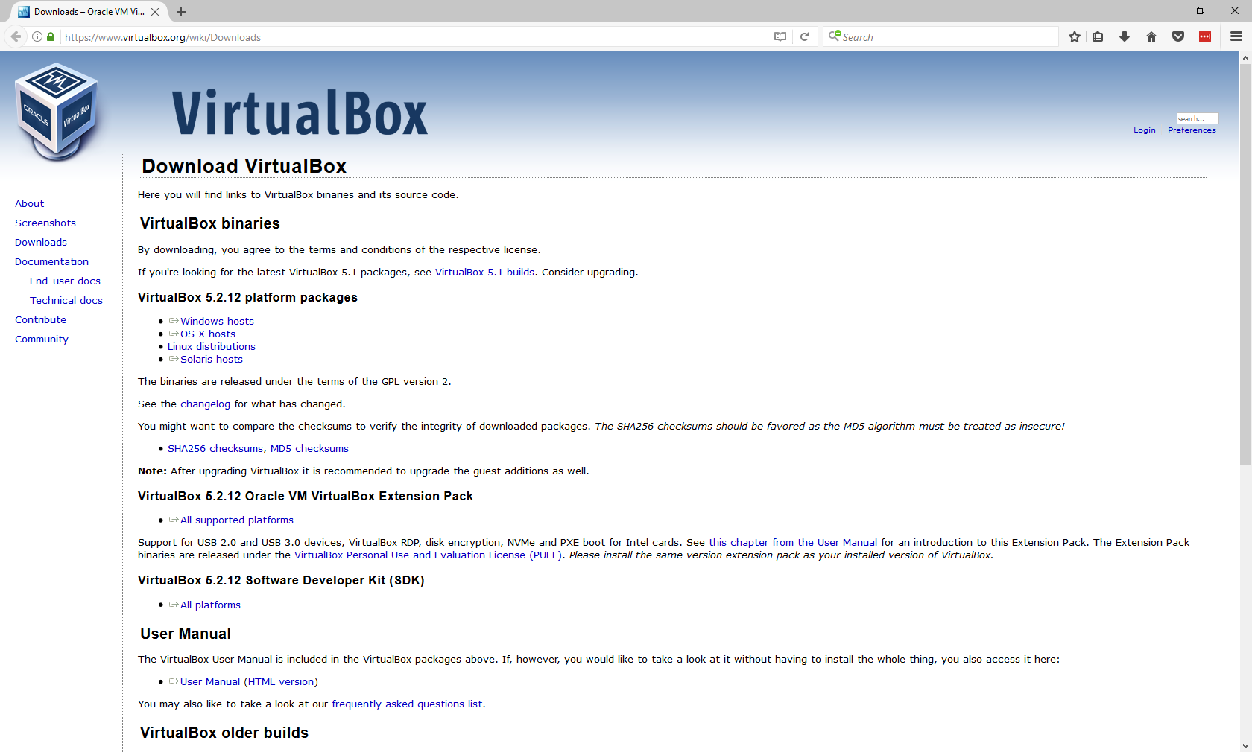

**Windows**

1. This will prompt you to save the file. Run the install file once saved.

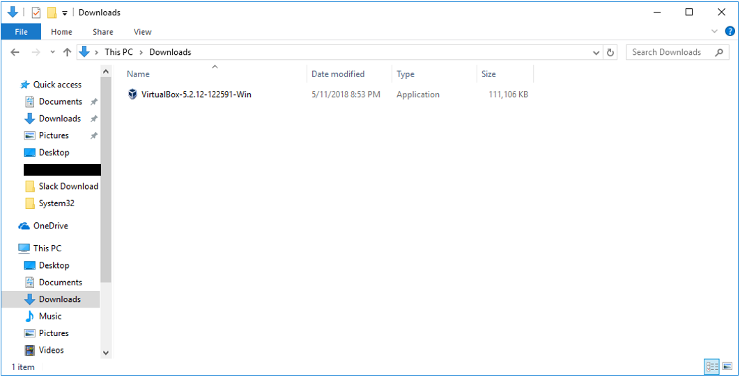

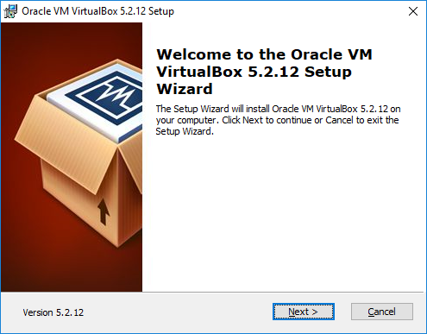

1. After you complete the installation, you will find VirtualBox amongst your applications in the Start Menu.

# Install VirtualBox on Mac

1. Go to <https://www.virtualbox.org/wiki/Downloads>
2. Click on OSX Host.

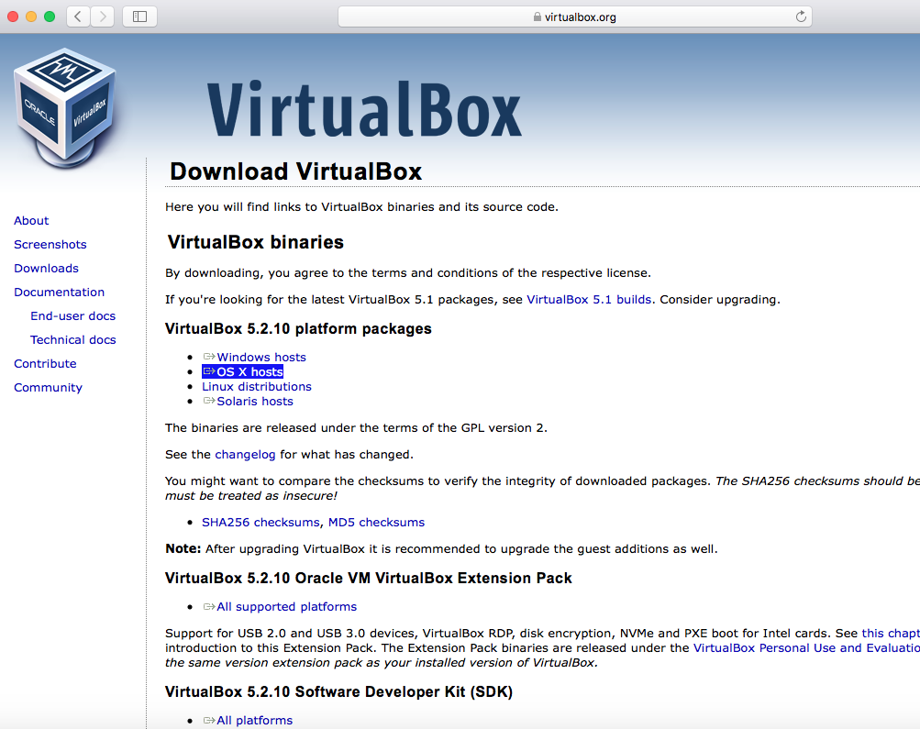

**Mac**

1. This will download the installation file. Go to your Finder and open the VirtualBox .dmg file

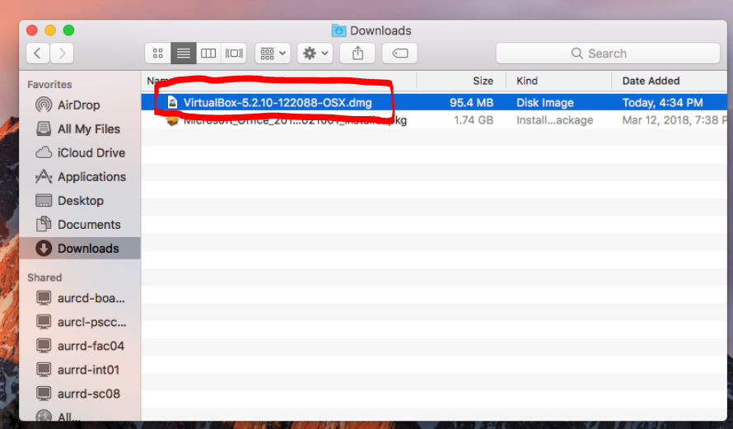

1. The installer will open – click on VirtualBox.pgk

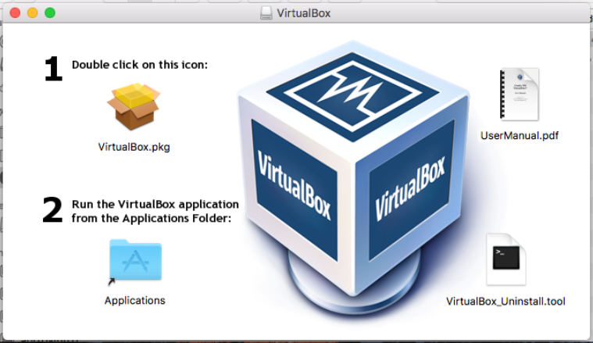

1. This will start the installation please click on the next box for the installation. Once completed VirtualBox will then be in your applications folder.

# Download a Copy of Windows 10

These instructions assume a 64 bit machine.

1. Go to <https://rasmussen.onthehub.com/WebStore/Welcome.aspx>

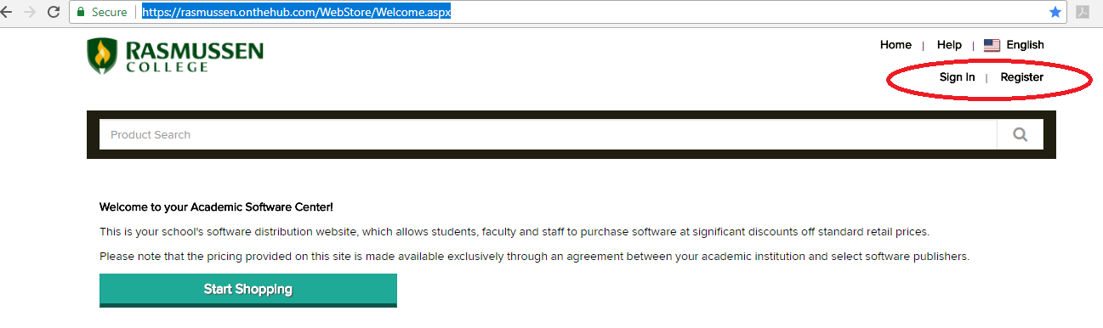

1. Enter your credentials and Click Sign In. (You may need to register first. You will use your Rasmussen email as a user name. If you need help registering or seeing appropriate items in the hub, contact PSC).

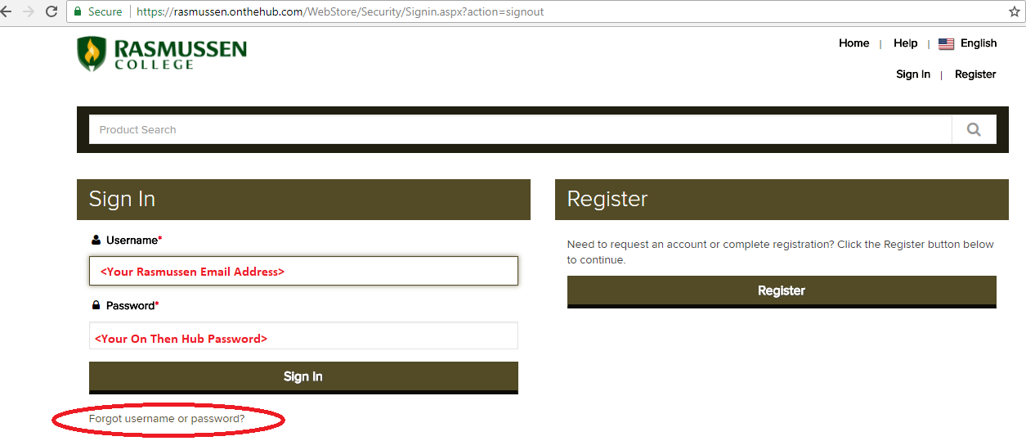

1. If you have already registered and you have forgotten your OnTheHub password, click on “Forgot username or password” at the bottom. Check your Rasmussen email for instructions on resetting your password. When you are finished resetting it, come back to this screen, enter your credentials, and Click Sign In.
2. In the new screen that appears, type “Windows 10” in the Product Search textbox at the top of the screen and press **Enter**. (Do not click Start Shopping at the bottom, press enter instead).

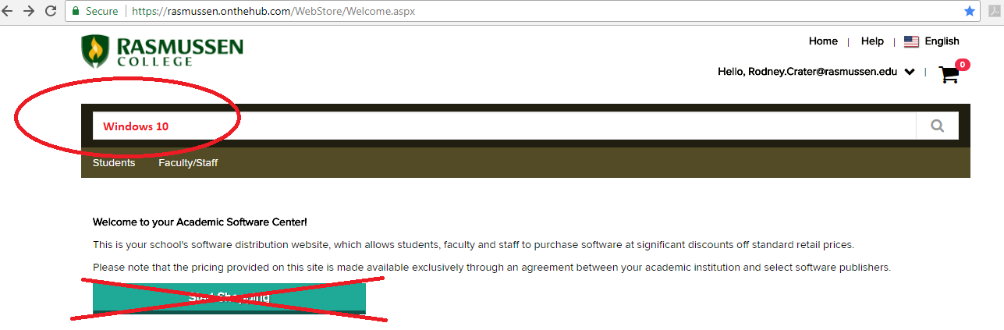

1. In the new screen that appears, you will see two different versions of Windows 10. Do not choose the United Kingdom version. Click on “Add to Cart” for the correct version.

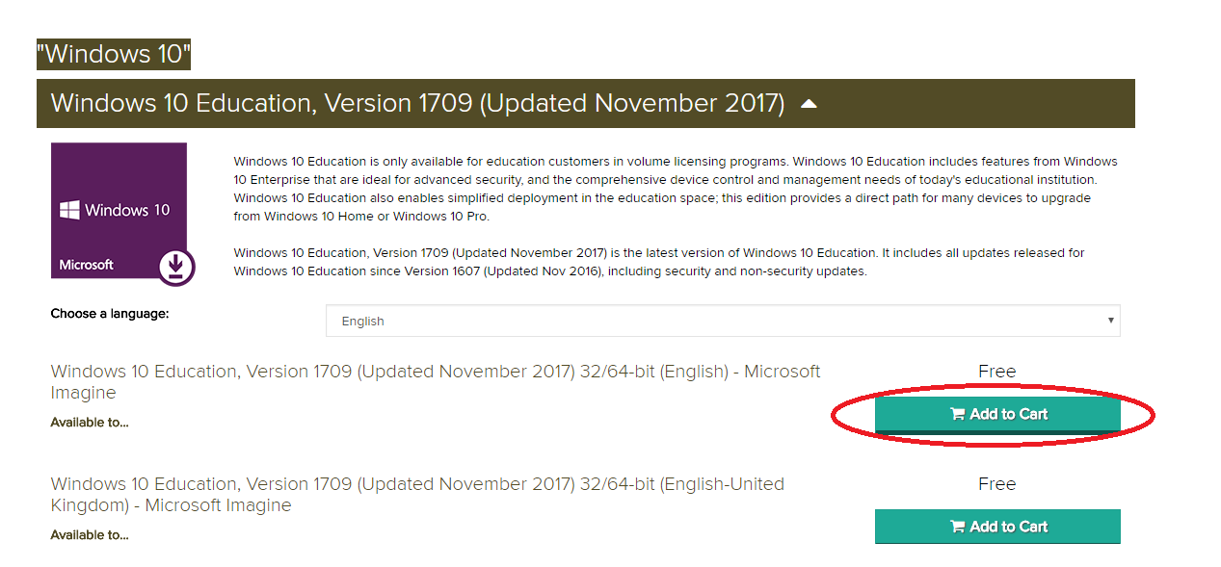

1. A new screen appears with a list of downloadable items.
2. Note the product key – you will need it when you install Windows 10 on your VM.
3. Click Download.

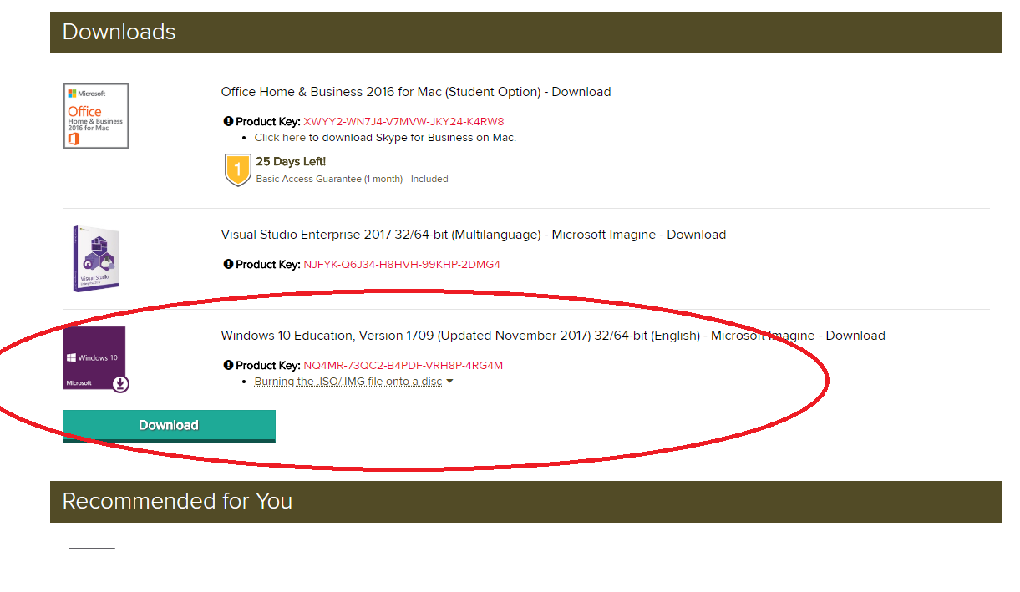

1. A new screen appears.
2. It is assumed that you have a 64 bit machine. Click the Download button for the 64 bit virtualization.

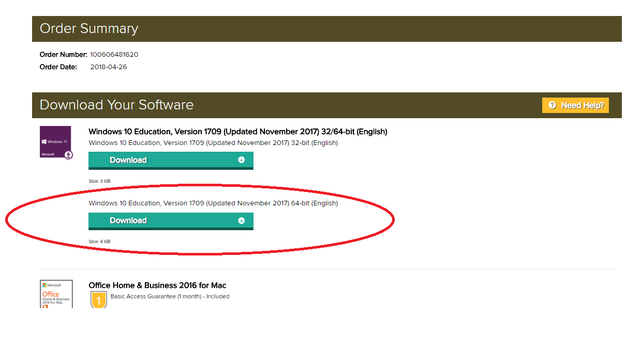

1. Save the file to an appropriate area on your computer where you can access it later.

This is what it will look like on a **Windows** based computer.

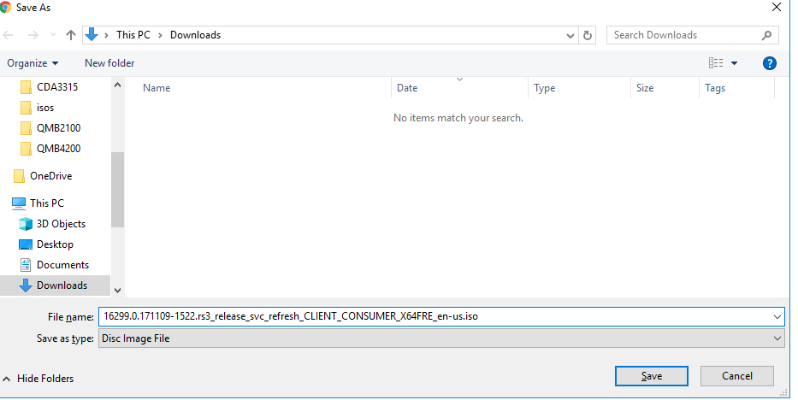

This is what it will look like on a **Mac** computer.

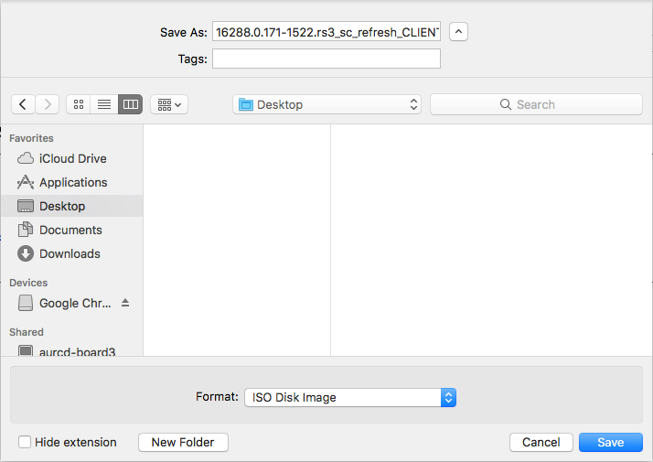

1. The file is an .iso file. This is fine. VirtualBox will be able to use an .iso file without burning it to a CD or DVD.

# Create a Virtual Machine

*Please note that Windows users may have to enable virtualization in BIOS. Each motherboard handles it differently. Please reference online resources on how to enable virtualization for your computer.

1. Open/Run VirtualBox.
2. The VirtualBox Manager window will appear.
3. Click on the New icon in the top left hand side of the screen.

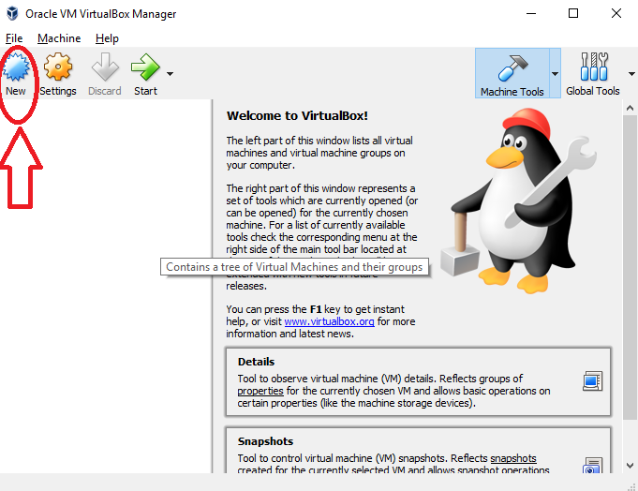

1. In the **Name** textbox, enter a name for your VM.
2. Make sure the **Type** is set to **Microsoft** **Windows**
3. Change the **Version** to **Windows 10 (64 bit)**
4. Click the **Next** button at the bottom

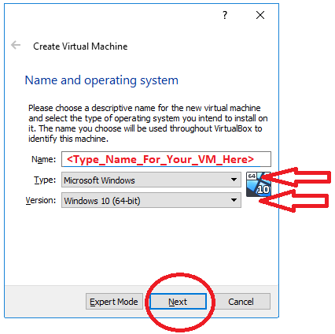

1. A memory allocation window will appear. You can leave the setting as they are. Click **Next.**

- This setting can be adjusted later if you find that the environment running slowly.

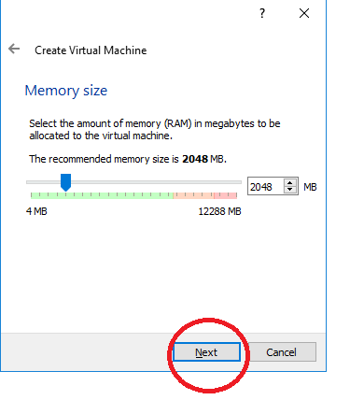

1. A hard disk creation window will appear.
2. Ensure that the **Create a virtual hard disk now** radio button is selected.
3. Click **Create.**

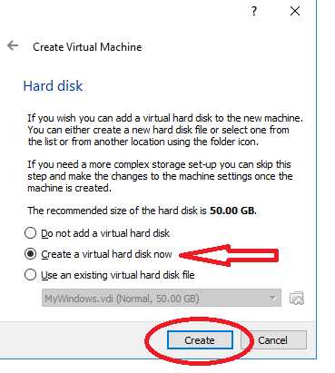

1. A Virtual Hard Disk creation window will appear.
2. Ensure that the **VDI (VirtualBox Disk Image)** radio button is selected.
3. Click **Next.**

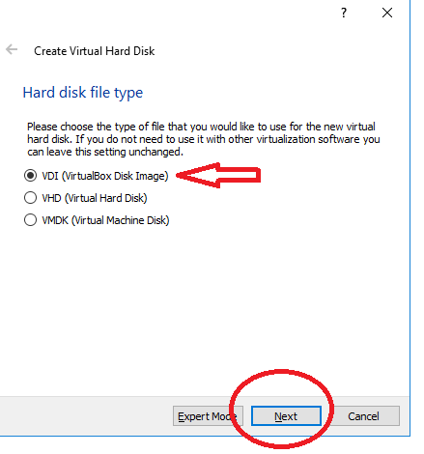

1. A storage options window will appear.
2. Ensure that the **Dynamically allocated** radio button is selected.
3. Click **Next.**

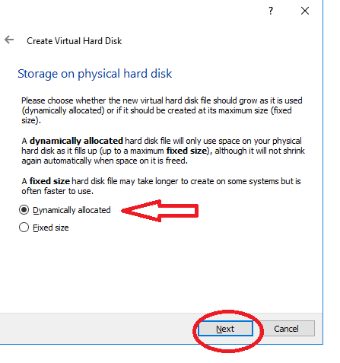

1. A Virtual Hard Disk name/location window appears.
2. Change the name of the **VDI** if desired.
3. Click **Create.**

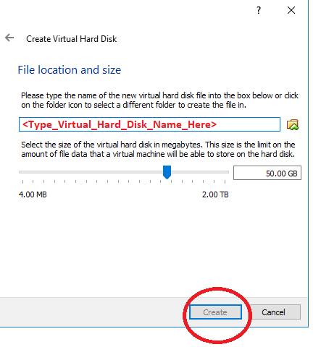

1. Your Virtual Machine is now created.

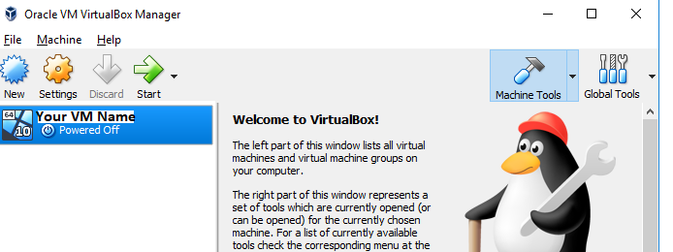

1. Next we will point to the .iso file so that when the Virtual Machine is started, it will boot from the .iso image so that the Windows 10 operating system is installed.
2. Click on the Settings icon at the top of the Manager window.

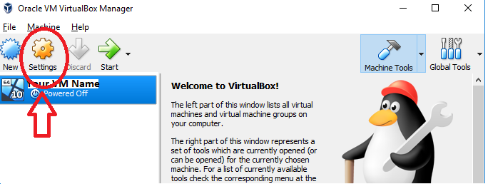

1. A Settings window will appear.
2. Click on **Storage.**

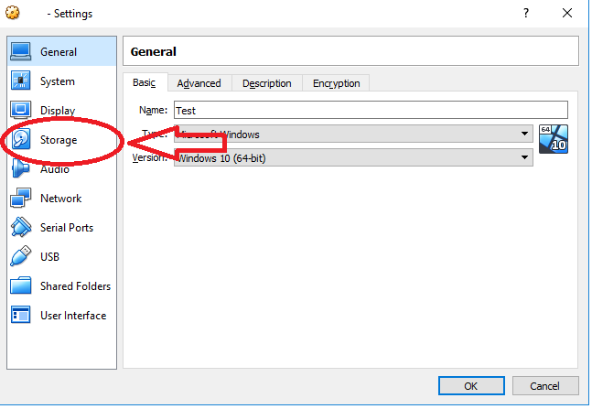

1. A Storage window will appear.
2. Click on the **Add Optical Drive** icon.

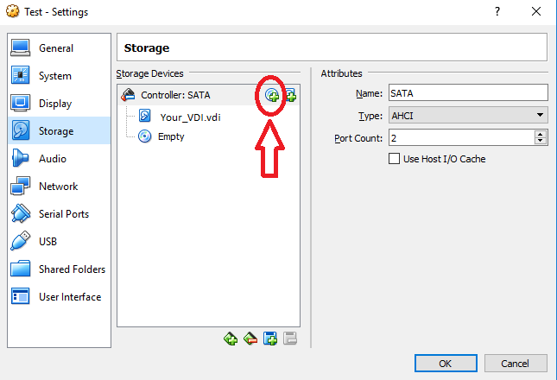

1. A question box will appear.
2. Click **Choose disk.**

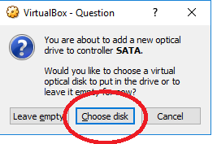

1. Navigate to the Windows 10 .iso file you downloaded earlier.
2. Select it and click **Open.**

Below is what it will look like on a **Windows** based computer.

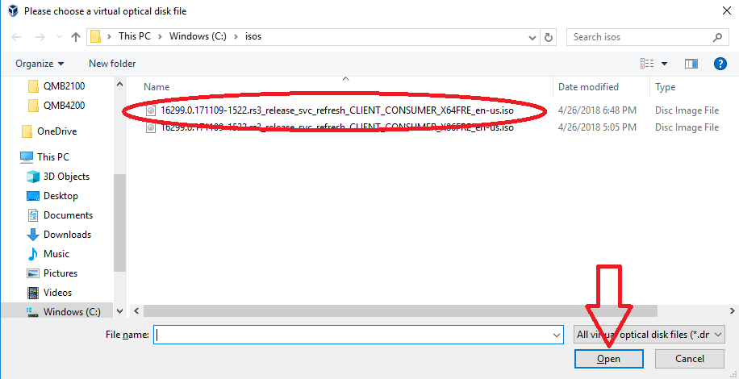

Below is what it will look like on a **Mac** based computer.

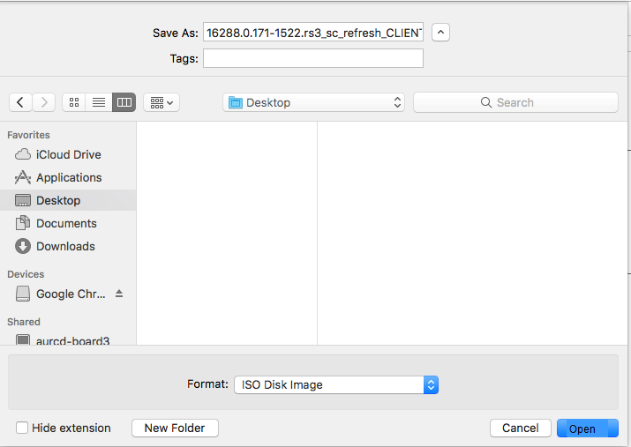

1. The Settings window will reappear with the .iso image mounted as an Optical Drive.
2. Clickon the **.iso drive** to select it.
3. Check the **Live CD/DVD** checkbox on the right.
4. Right Click on the Empty Optical Drive and Remove.
5. Click **OK.**

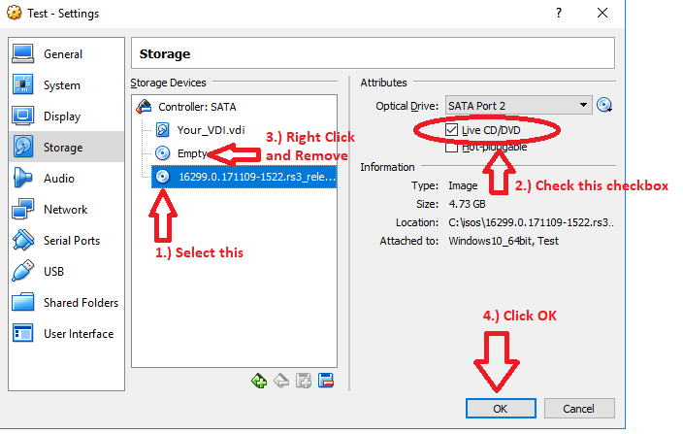

1. The VM Manager window will reappear.
2. Click **Start** to begin installing Windows 10 on your VM.

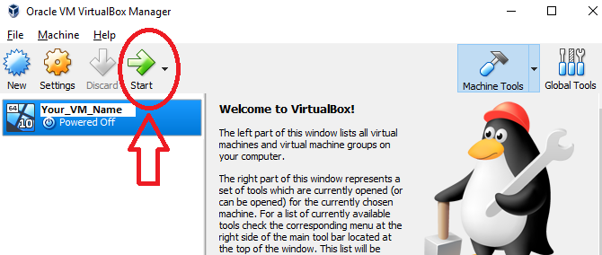

1. The VM will start up and begin the Windows 10 installation process.
2. Proceed with the Windows install process, answering all questions.